Parsonage Farm Nursery and Infant School,
Cherry Tree Close,
Cove,
FARNBOROUGH,
Hants
GU14 9TT

Headteacher
Miss K Greenway

Telephone: 01252 548003
Fax: 01252 518380
E-mail: headteacher@parsonagefarm.hants.sch.uk
http://www.parsonagefarmschool.co.uk

17th April 2026



Dear Parents,
I hope you all had a good Easter break and enjoyed some family time. The weather was great for some of the holiday so hopefully you got out and about and enjoyed the sunshine! The children have come back to school with their batteries recharged and ready for another busy term.

Please note that the dates for events this term are at the bottom of the newsletter. Please add them to your calendar.

Bike Shelter
The bike shelter by Year 1 and Year 2 classes will be used next week to store bikes for Year 1 bike training. If you would normally use this, please can you support your child to leave their bike or scooter in the bike shelter in front of the Community Hall. Thank you for your help with this.

Nursery and Year 2 Parents
If your child is in Nursery or Year 2, you will have received your email saying where they have a place for next year. If your child is in Daisies, please don’t forget to bring in your proof of address and birth certificate (or take to your new school if your child is not coming to Parsonage Farm) – this must be done by Thursday 30th April. After you have done this, you will receive an email with information about transition events and some online forms to complete as soon as possible.

If your child is in Year 2, you should receive information soon from the junior schools about their planned transition events.
Any questions, please speak to Mrs Parkhouse or Mrs Wraight in the School Office.

Smartphone Free Meeting for Parents
Last year I sent information in the newsletter about the Smartphone free Childhood campaign which we are supporting as a local cluster of schools. As you are aware, the Government are also reviewing the age for the use of social media.
Did you know:
- Around 24% of 3- and 4-year-olds have their own smart phone
- 12- 15-year-olds in the UK now spend an average of 35 hours a week on their smart phone – the same as a working week!
There is a growing number of parents who believe that childhood is too short to be spent on smart phones and who have signed a pledge to wait until at least Year 9 to give their child a smart phone. If you are interested in knowing more or finding out about the research that has been done, click on the link - https://smartphonefreechildhood.co.uk/ or join the virtual meeting that we have organised as a cluster of school on Tuesday 21st April from 7 – 8.30pm.
Direct link to meeting: Join from Zoom Workplace app - Zoom

Relationship and Sex Education – Parent consultation
From September 2026, schools must follow new DfE guidance on the teaching of Relationship and Sex Education. We would like to find out more about what you already know to help us guide the next stages of our consultation process. Please could you click on this link to complete a questionnaire: https://forms.office.com/e/tM779TZCp6. Please complete by Friday 1st May. Thank you.

SCARF
Nursery and Year R: Family SCARF - SCARF at home - Being my best 3-5 years
Year 1 and Year 2: Family SCARF - SCARF at home - Being my best 5-7 years

This half term the theme in our SCARF lessons is ‘Being my best’. Above are the links to suggested family activities, talking points and some games or worksheets (there is no expectation to print these off). We would love to see any of the activities you do, so please do send things in with your child or email any photos to your year group email address.

What is my child learning in school?
Each half term information is added to the website to inform you of what your child will be learning in school. Please follow the links below to access the relevant information for your child/children.

Daisies: Nursery-Curriculum-Grid-for-Parents-Summer-1.387630386.pdf
Year R: Year-R-Curriculum-Grid-For-Parents-Summer-1-26.387630417.pdf
Year 1: Parsonage Farm Nursery and Infant School - Summer Term 1
Year 2: Parsonage Farm Nursery and Infant School - Summer Term 1

Attendance
As I have mentioned in several newsletters, our attendance is sent directly to the Government every day. Our whole school attendance from September until now is 95.7% and the national average is 94.4%, so well done everyone – let’s keep this up until the end of the school year!
I have analysed this in more detail and have emailed parents that I would like to meet with to discuss their child’s attendance

Safety
As mentioned in my last newsletter, we have received some great posters from the Child Accident Prevention Trust as accidents remain one of the leading causes of serious injury for young children. We thought we would add one of their posters to each newsletter. This week, we have chosen Fire Safety.

Nursery Places September 2026
We still have some places available for September 2026 so please ask for an application form in the school office. If your child was born between September 2022 and August 2023, they could start in Daisies in September 2026.

Parent Courses
The Library Service is running more free online courses for parents
- Raising Resilient Children
- Stepping into School
- Positive Parenting
Please see the attached poster

Hampshire CAMHS is also running several face-to-face events/information sessions to equip parents to support their child’s mental health. Unfortunately, none of these are very local but I have included the link if you are interested.
https://hampshirecamhs.nhs.uk/events/

Message from FOPS
Please remember to bring back your smartie’s tubes for the FOPS Easter Challenge. We will be counting the money raised and a treat will be given to the class who has raised the most.

We are currently planning our Colour run event - Please save the date - Sunday 28th June. Tickets will be going on sale shortly.

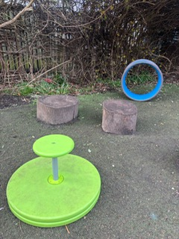
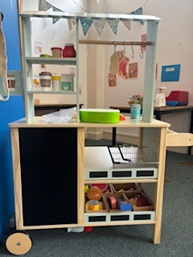
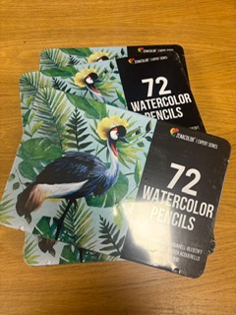
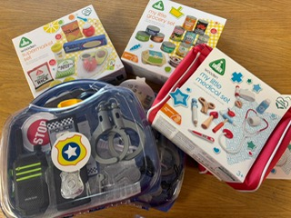
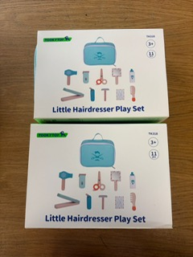
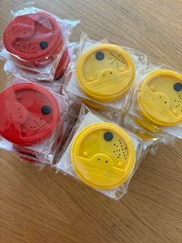
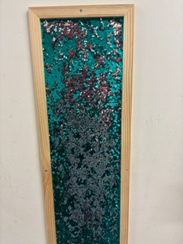
Over the past few weeks, we have been busy spending money on various things around the school. Below are just a very few of the items that have been bought with the yearly class donations and the money raised from the Christmas rotary collection:

Request
- Does anyone have or know someone who might have a spare garden strimmer that they no longer require and would be willing to donate it to the school please. Thank you!
Reminders
- Our weather is very changeable, so please make sure your child has a coat with them – at least until the weather really warms up!
- Please NAME jumpers and cardigans – there are so many unnamed ones left in corridors, and we cannot return them to the right child!
As always, any questions about anything, please just ask.

Have a lovely weekend.
Miss Greenway

Dates for Diaries
Mon 20th – Fri 24th Yr 1 Bike ability

Tues 21st April 7 – 8.30pm Smartphone Free Meeting for Parents

Fri 15th May Class Photos

Mon 18th – Fri 22nd May Walk to School Week

Mon 25th – Fri 29th May Half Term (ACEKids Holiday Club running– Home - ACE Kids)

Thurs 11th June Yr R Trip to Milestones, Basingstoke

Mon 15th June Yr 2 Trip to Beale Park, near Reading

Fri 26th June 8.45 – 9.30am KS1 Book Viewing
2.40 – 3.15pm KS1 Book Viewing

Sun 28th June FOPS Colour Run

Mon 29th June – Thurs 2nd July Drop off/pick up Nursery and Yr R Floor Book Viewing

Thurs 2nd July am ‘Move up’ Day – visit new class/new school

Friday 3rd July INSET DAY (ACEKids running)
Monday 6th July INSET DAY (ACEKids running)

Tues 7th July Yr 1 Trip to Wellington Country Park
7pm New Yr R Parents meeting

Fri 10th July pm Rocksteady Concert

Mon 13th July 7pm New Nursery Parent Meeting

Wed 15th July am Yr 2 Leavers Assembly
pm Yr 2 Leavers Disco

Fri 17th July am Sports Day
2.30pm Golden Rabbit Assembly

Wed 22nd July 1.15pm School Finishes

Year Group Emails
Daisies - nursery@parsonagefarm.hants.sch.uk
Poppies and Snowdrops – yearr@parsonagefarm.hants.sch.uk
Tulips and Sunflowers – year1@parsonagefarm.hants.sch.uk
Bluebells and Daffodils – year2@parsonagefarm.hants.sch.uk

