Parsonage Farm Nursery and Infant School,
Cherry Tree Close,
Cove,
FARNBOROUGH,
Hants
GU14 9TT

Headteacher
Miss K Greenway

Telephone: 01252 548003
Fax: 01252 518380
E-mail: headteacher@parsonagefarm.hants.sch.uk
http://www.parsonagefarmschool.co.uk

1st May 2026



Dear Parents,
It has been lovely to see all the children enjoying lots of outdoor learning over the last 2 weeks and the good weather has helped. Our school grounds are beginning to look more colourful with blossom and flowers starting to grow.

Sunny Weather
As the weather is getting warmer, please can you remember to send your child with a sun hat, put sun cream on them before they come to school if you think they need it and make sure they have a water bottle. Thank you for your help with this.

Year 1 Bike Training
Year 1 enjoyed having the bike team visit last week. We are very proud of all children in Tulips and Sunflowers as they continuously demonstrated our blue value 'we try our best even when it is hard'. We were very impressed by their perseverance and their determination. It was lovely to see each child make significant progress at a rate that suited them. Each child listened and followed the instructions well. They were a credit to you and to our school. We were pleased to see their self-satisfaction and pride once they had achieved their goals.
I am proud because I can ride a bike now

I liked it because we got to glide
I liked using one hand to signal

I struggled on the pedal bike but I finally did it

I learnt to pedal and I couldn’t before
I liked it when we played the car game
I liked it on the big bikes. It was so much fun

When we went through the cones it was hard and easy. It

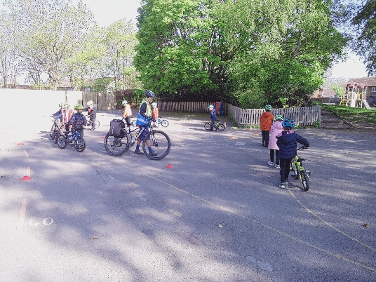
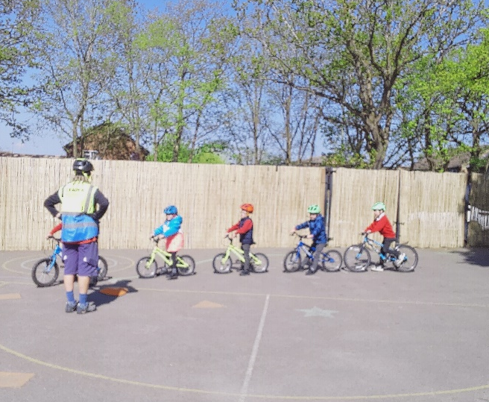

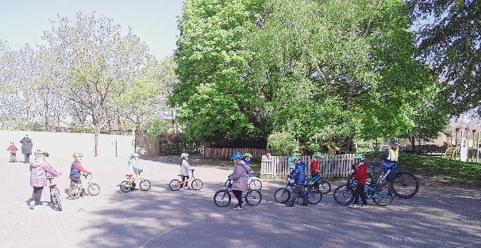

Walk to School Week: Monday 18 May – Friday 22 May 2026
From Monday 18th May to Friday 22nd May, it is Walk to School Week and we will be encouraging as many children as possible to walk, cycle or scoot to school. Whilst we hope many of you can do this, we appreciate that some of you cannot avoid driving. If you have to drive, please consider ‘parking and striding’ – which means parking safely further away from the school and walking the remaining distance. Alternatively, just going on walks in the evenings and weekend would be a fun option too. This week is a perfect opportunity for you to discuss the green cross code with your children and practise those key pedestrian skills as well as promoting the health and environmental benefits of walking. We will be learning about this in school too and the children will come home at the end of the week with a certificate to show that they have taken part.

Message from FOPS
Thank you for returning all the smartie tubes with coins in. Well done to all the children who did little jobs at home to earn coins to put in their smartie tube.
Well, done to Snowdrops class who raised the most money and thank you to everyone who took part – it raised an amazing £503.12.

Summer Disco
Date: Friday 15th May
Doughnuts for Dads
Date: Friday 19th June
Colour Run
Date: Saturday 28th June

Tickets are now live www.pta-events.co.uk/fops1

Daisies Parents
Thank you for bringing in your paperwork to confirm your child’s place in Year R in September. Please don’t forget to complete the online forms as well – the links were on the email you would have received from Mrs Parkhouse. Please complete these as soon as possible to allow for maximum transition.
Please note Daisies will be closed on Thursday 2nd July as it is move up day and the new Daisies children will be visiting their new reception classes either here with us or their new school.

Neurodiversity and Wellbeing
The Hampshire Neurodiversity and Wellbeing Multi-Disciplinary Team (NDW MDT) supports parents and carers of children and young people aged 9 months to 19 years as well as professionals. They help families understand how a child or young person’s emotions, responses, thinking patterns, and behaviours may relate to neurodivergence. They have developed a Neurodiversity Hub as it can feel overwhelming when you think your child might be neurodivergent and you may have questions, worries, or feel unsure about what help is available. Follow the link below for a wealth of information and resources.
Hampshire Neurodiversity and Wellbeing Multi-Disciplinary Team | Hampshire CTSH

Relationship and Sex Education – Parent consultation
From September 2026, schools must follow new DfE guidance on the teaching of Relationship and Sex Education. We would like to find out more about what you already know to help us guide the next stages of our consultation process. Thank you to all the parents who have already completed the questionnaire – today is the last day for doing this. https://forms.office.com/e/tM779TZCp6. Thank you.

Safety
As mentioned in my last newsletter, we have received some great posters from the Child Accident Prevention Trust as accidents remain one of the leading causes of serious injury for young children. We thought we would add one of their posters to each newsletter. This week, we have chosen Safe Around Roads.

Lateness
Since the Easter holidays, we have had more and more children being brought to the school office, any time between 9am and 9.30am. Please remember all children need to be in school before 9am. Our attendance, including lateness, is sent to the DfE every day and monitored.
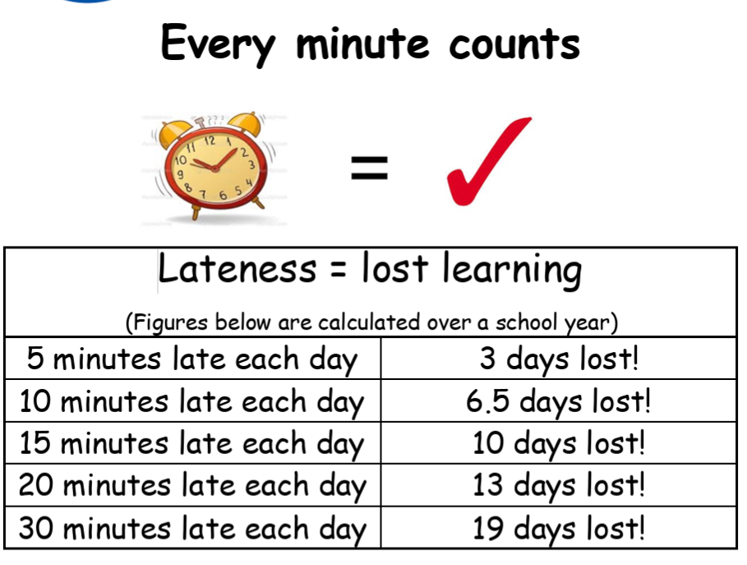

If your child arrives late for class:
- They don’t have the social time to settle into class.
- They miss out on important learning, which could affect their achievement.
- It can be embarrassing for them as they like to be the same as their friends.
- They may disrupt the learning of the rest of the class.
Nursery Places September 2026
We still have some places available for September 2026 so please ask for an application form in the school office. If your child was born between September 2022 and August 2023, they could start in Daisies in September 2026.

Reminders
- Please make sure your child walks with their bike or scooter once in the school grounds – unfortunately a child was hurt this week by a child riding their scooter in the school grounds, which can be seen on CCTV. This applies when you pick up from after school clubs too.
- Our weather is very changeable, so please make sure your child has a coat with them – at least until the weather really warms up!

As always, any questions about anything, please just ask.
Have a lovely weekend.

Miss Greenway

Dates for Diaries

Mon 4th May Bank Holiday – School Closed
Fri 15th May Class Photos
FOPS disco
Mon 18th – Fri 22nd May Walk to School Week

Mon 25th – Fri 29th May Half Term (ACEKids Holiday Club running– Home - ACE Kids)

Thurs 11th June Yr R Trip to Milestones, Basingstoke
Mon 15th June Yr 2 Trip to Beale Park, near Reading
Fri 19th June FOPS Doughnuts for Dads
Fri 26th June 8.45 – 9.30am KS1 Book Viewing
2.40 – 3.15pm KS1 Book Viewing
Sun 28th June FOPS Colour Run
Mon 29th June -Thurs 2nd July Drop off/pick up Nursery and Yr R Floor Book Viewing
Thurs 2nd July am ‘Move up’ Day – visit new class/new school – Daisies CLOSED
Friday 3rd July INSET DAY (ACEKids running)
Monday 6th July INSET DAY (ACEKids running)
Tues 7th July Yr 1 Trip to Wellington Country Park
7pm New Yr R Parents meeting
Fri 10th July pm Rocksteady Concert
Mon 13th July 7pm New Nursery Parent Meeting
Wed 15th July am Yr 2 Leavers Assembly
pm Yr 2 Leavers Disco
Fri 17th July am Sports Day
2.30pm Golden Rabbit Assembly
Wed 22nd July 1.15pm School Finishes

Year Group Emails
Daisies - nursery@parsonagefarm.hants.sch.uk
Poppies and Snowdrops – yearr@parsonagefarm.hants.sch.uk
Tulips and Sunflowers – year1@parsonagefarm.hants.sch.uk
Bluebells and Daffodils – year2@parsonagefarm.hants.sch.uk

