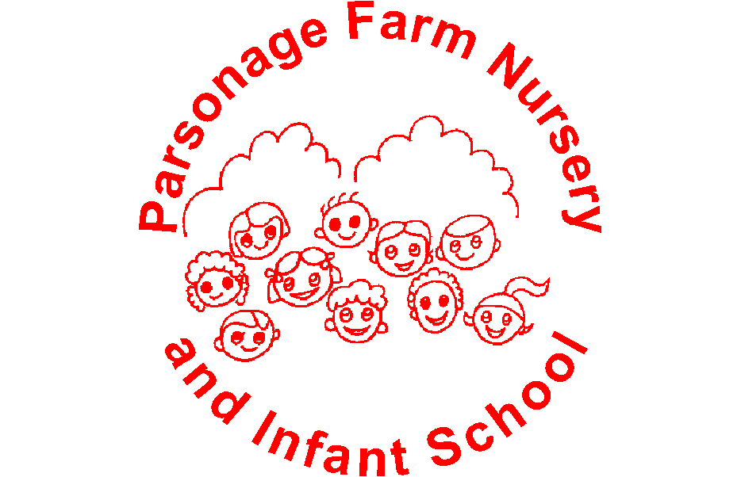

Teaching and Learning Policy

Intent
At Parsonage Farm Nursery and Infant School, everything we do is underpinned by our vision and values.
Our vision
‘We aspire for all at Parsonage Farm to feel valued and cared for, to have a continued excitement for learning, ensuring success as they journey onwards.’
Our values
We can follow the rules to keep us happy and safe
We respect ourselves, others and our school
We can make the right choices
We can concentrate and listen well
We try our best even when it is hard
We think about the feelings of others
OUR PROMISE
“We will always listen to you.”

At Parsonage Farm, we believe that every child is an individual and should be supported to become a confident, resilient, independent, lifelong learner and encouraged to ‘be the best that they can be.’
Our aim is for all children to leave Parsonage Farm with a sense of belonging to a community where they have developed the confidence and skills to make decisions, make connections and become lifelong learners, so that they are prepared for the next stage in their education.
Implementation

Learning Ethos
A positive attitude to learning is essential in becoming a successful learner. We believe children learn best when:
- They feel happy, safe and secure and their self-esteem is high
- They feel respected and know that they are listened to and their views are valued
- They are guided, supported and encouraged by those around them
- Positive relationships exist between home and school
- Learning is given a purpose and context and children understand the learning journey
- The level of challenge is ‘just right’ in order that they remain motivated to learn more
- They are encouraged to be independent learners, to think for themselves and ask their own questions
- They are encouraged to take risks and know that ‘it is ok to make a mistake’
- They know that they ‘may not be able to do it yet’ but with effort, support and practice, they will learn

Principles of High quality, inclusive teaching
High quality learning comes from high quality teaching. We ensure we both motivate children and build on their prior knowledge, skills and understanding. To do this we ensure that all teaching sessions and sequences of learning must contain the following principles:
- Strong, positive relationships within the learning environment- positive and effective adult to child and child to child interactions
- Understanding each child and their contexts, their personalities and ways of working with each child to gain positive engagement
- High expectations of all children which are enacted in the teaching and learning they experience; adults believing that every child can make accelerated progress if the appropriate conditions are in place, through a personalised approach
- Ongoing, responsive, diagnostic assessment, monitoring and reviewing, which informs and shapes the teaching and learning in real time, including:
- pre-teaching, which acknowledges different starting points and attempts to enable all children to access the core teaching and learning
- flexible groupings to promote active pupil engagement with their learning
- flexibility in teaching and learning to adjust and personalise in response to each child
- Skilled, open-ended questioning, asking the right questions at the right time to reveal understanding and any misconceptions, in order to build further on learning
- The explicit teaching of key vocabulary to assist in conceptual understanding and building knowledge
- Variation in how learning and understanding is communicated and recorded
- A physical environment which is conducive to learning, taking into account such aspects as sensory needs
- The use of equipment, practical demonstration and concrete representation to support learning alongside explicit teaching of how to use different resources to support learning
- Skilled deployment of any additional adults to support learning, independence, self-regulation and metacognition

Children in our Nursery and Reception classes follow the Early Years Foundation Stage Curriculum and those in Year 1 and Year 2 follow the National Curriculum.
We have carefully created our curriculum to meet the needs and learning styles of all children. It has been designed around a set of progressive knowledge and skills, but the context in which these are delivered is tailored to each cohort of children dependent on their interests and needs. The knowledge and skills are planned so that the sequence enables children to know more, do more and remember more. It is purposeful and meaningful for the children in our school at this time, based on first hand experiences and provides memorable experiences.
Teachers plan whole class, small group, paired and individual learning activities, depending on the needs of the children and the topics to be covered. Groupings are constantly reviewed and teachers monitor children’s progress and adjust their planning and teaching accordingly. When planning for children with SEND, this may include using information and targets from their Individual Education Plans.
Assessment for learning checks for understanding and ensures progress is being made. This is based on a wide variety of strategies listed in our assessment policy.

Effective planning, teaching and evaluation across the school may:

- ensure that learning outcomes are shared with all learners;
- give learners opportunities to choose ways of working and the opportunity to shape the direction of their learning;
- give pupils first-hand experiences through visits and visitors;
- include outdoor learning
- use stimulating starting points including artefacts, problems, stories and topical events;
- make activities relevant to children’s lives;
- build on what pupils find interesting and have experienced both in and out of school;
- use a range of learning styles, including practical investigations, problem-solving, role-play, visual aids, small group discussion and collaboration;
- use a range of resources which reflect the diversity of society;
- look for opportunities to encourage children to apply their prior learning creatively;
- give pupils opportunities to reflect on and share personal experiences and feelings;
- plan for pupils to share their work with others;
- give pupils opportunities to work with others from their class, year group and different age groups;
- plan, manage and monitor collaborative activities carefully;
- address the needs of individuals within groups;
- help children to develop criteria for evaluating the value of their own and others work;
- capitalise on unexpected learning opportunities and change the direction of a lesson where this is most effective;
- ask open ended questions;
- model flexible and independent thinking for children;
- discuss problems children are facing and how these can be solved;
- incorporate effective use of ICT;
- use assessment to inform future planning.

A variety of teaching strategies will provide opportunities for the children to:

- use their knowledge and prior experiences;
- reapply their learning in new contexts;
- communicate their ideas in new ways;
- use their imagination;
- look at things from different points of view;
- feel secure and supported emotionally;
- evaluate what they do and what they may do next;
- review their own progress;
- put forward ideas and explanations;
- listen carefully to feedback and incorporate this into their thinking;
- collaborate effectively with others.

Impact
We believe that enjoyment of the curriculum promotes achievement, confidence and high levels of engagement.
High quality, inclusive teaching ensures:
- Teaching is consistently good for all groups of children
- High levels of attainment and progress
- A positive climate for learning in all classrooms
- Children who are motivated and have a love of learning

Monitoring and Evaluation
This policy will be monitored and evaluated by:
- Senior Leadership Team
- Governors

Its effectiveness will be monitored and evaluated through lesson visits and pupil progress meetings. The policy will, where necessary, be revised in light of these evaluations.

This Policy should be read in conjunction with the Assessment Policy, Marking Guidelines, Principles of High Quality Inclusive Teaching, Behaviour Policy and SEND Policy.

Next Review Date: July 2027

