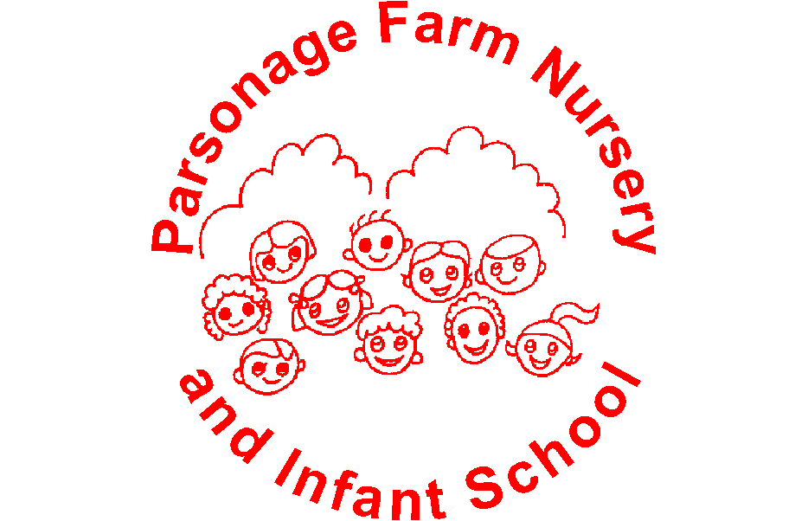

Parsonage Farm Nursery & Infant School
Assessment Policy

Our Vision
‘We aspire for all at Parsonage Farm to feel valued and cared for, to have a continued excitement for learning, ensuring success as they journey onwards.’
Intent
At Parsonage Farm Nursery and Infant School, everything we do is underpinned by our vision and values.
Assessment of any kind should ultimately improve learning and raise standards. It is a continuous process that is central and integral to the process of teaching and learning. It identifies what the child knows and can do and provides information to inform future teaching and learning in response to a child’s needs.

Assessment Principles
We believe that good assessment practice ensures that:
- Teachers plan learning tasks that are based on an analysis of children’s learning needs and accurately reflect the next steps in learning for each child
- Children demonstrate through their learning tasks what they know, understand and can do
- Children understand the next steps in their learning and take responsibility for their learning
- If children need support and intervention, this is identified at the earliest opportunity and the necessary steps are taken
- Parents/carers are provided with information which enables them to support their child’s learning so that school and home can work together to raise standards
- The headteacher, governors and other senior leaders have information which allows them to monitor and make judgements about the effectiveness of the school and use this information to inform school improvement planning
Our curriculum follows the principles of the national curriculum and early years foundation stage curriculum. Teachers ensure that children have a secure understanding of key ideas and concepts before moving on to the next phase of learning
Implementation

At Parsonage Farm Nursery and Infant School, we believe that the cycle of ‘plan, do, assess, review’ is integral to the everyday teaching and learning process, with all teaching linked clearly to on-going and responsive assessment.
Teachers/all staff constantly adapt the learning environment and their teaching in light of the information they gain from observations, questioning and feedback from children. As part of this process, children are given feedback (mainly verbal, sometimes written) on their learning so that they know how successful they have been and what the next steps are.

Assessment for Learning
AfL is used by teachers to evaluate children’s knowledge and understanding of a concept or skill on a day to day basis and then adapt their teaching accordingly.

AfL is about:
- Providing effective feedback to children – including supporting them to understand how they can improve
- Actively involving children in their learning
- Adjusting teaching to take account of the results of assessment
- Recognising that assessment has an impact on children’s motivation and self-esteem

Strategies used could include:
- Questioning
- Observations
- Paired talk
- Feedback - verbal
- Marking – tickled pink (well done for… ) and green to grow (next steps)
- Time for editing (Purple polishing pens)
- Pre-teaching
- Flexible Groupings
- Flexibility in teaching and learning - personalised in response to each child
- Entry and exit tickets
- Flash backs
- Peer and self assessment

Summative Assessment (Tracking)
Summative assessment may take place at the end of a unit of work to assess children’s understanding and inform planning. There are also key points during the year where assessment information is collected to form an overall summative assessment.

Phonics assessments are completed every half term (5-6 weeks) for all year groups.

Each half term, EY teachers complete Venn Diagrams to show if each child is showing typical development for the Prime areas and from February half term, Reading, Writing and Maths.
Key Stage 1 teachers complete Venn diagrams for Reading, Writing and Maths, identifying those children on track/not on track based on what has been taught each half term.

In Key Stage 1, Foundation subjects are assessed at the end of each unit, with key knowledge and/or skills identified on knowledge organisers. Children are assessed as on track/not on track.

Statutory Assessment
Children undertake the Department for Education (DfE) phonics screening at the end of Year 1, and again in Year 2 if they have not been successful. This information is reported to parents in end of year reports.
On entry, each Yr R child will complete the Reception Baseline Assessment. At the end of Year R, we complete a child’s Early Years Foundation Profile by assessing whether a child has met or not met each of the 17 Early Learning Goals.

Marking and Feedback
All staff follow the school marking guidelines and marking keys (Appendix 1).

The response required by the child to marking and feedback must always be appropriate to their age or stage of development. Whenever possible, feedback and marking should be completed with the child as a ‘real time’ assessment. Evidence of the impact pf feedback should be seen in subsequent work, or later on in the same piece of work.

Pupil Progress Review Meetings
From the Venn Diagrams, Pupil Progress Review forms are completed for all children not on track in any area and also for those children who have been identified as needing extra support or interventions.
Pupil Progress Meeting with HT, DHT and SENCO take place in October to discuss children not on track and barriers to learning and are then followed up through lesson visits and learning walks. Pupil Progress Review forms are updated half termly to show what’s working well and what adjustments have been made.

Moderation
- Regular internal moderation in year groups, during PPA. This informs tracking on Venn diagrams and agreement of whether children are on track/not on track
- External moderation – often termly – in cluster groups
- attendance at LA sessions – EY/KS 1/ assessment network

Reporting
All parents will receive an end of year report for their child.
In EY, this will include information about all areas of learning and in Year R, state whether their child has achieved the Early Leaning Goal for each of the areas of learning.
In Key Stage 1, this will include information about all subjects and whether their child is on track/not on track based on National Curriculum expectations.
All reports will include information about a child’s personal development.

Monitoring
Subject leaders will monitor their subject through:
- Looking at planning/knowledge organisers
- Book/floor book scrutiny
- Learning walks
- Pupil Conferencing
- Half termly assessments provided by class teachers – children on track/not on track

Through analysing half termly assessments, subject leaders will support staff with future planning to enable those children not on track to make progress towards or to achieve identified knowledge and skills.

All monitoring information will be recorded on agreed template forms and reported back to SLT. It will inform subject action plans and help to raise standards within their subject area.

Governors will monitor through book scrutiny and reports to Learning Partnership group.

Impact
Accurate and effective assessment, marking and feedback will:
- Raise standards of attainment
- Enable children to be actively involved in their own learning by providing effective feedback
- Increase children’s self-esteem through a shared understanding of the learning process and how to improve
- Enable teachers to adjust teaching to take account of assessment information thus reducing barriers to learning
- Identify those children not on track and in need of support
- Provide the Headteacher, Governors and SLT with necessary information to support school improvement planning
- Ensure parents are kept informed about their child’s progress

This Policy should be read in conjunction with the School’s Marking Guidelines, Teaching and Learning Policy, Principles of High Quality Inclusive Teaching

Issue Date: April 2024
Review Date: April 2026

Appendix 1

Marking Guidelines

Aims:
- To ensure a consistent approach to marking children’s work throughout the school
- To mark children’s work in such a way as to allow children to celebrate successes and identify next steps for learning

When marking children’s work all staff should follow the Marking Guidelines. This will help to ensure we are all using a standard approach to marking and will provide clarity for children, teachers, LSAs, parents and governors.

- Each piece of work needs to be initialled and dated
- The marking key (stuck in the front of Writing and Maths books) should be followed at all times
- Children should be given time to respond to marking using editing pens if appropriate
- LSAs should mark the work of the group they are working with unless otherwise instructed
- There should be a variety of teacher marking and LSA marking in each book
- It is at the discretion of the class teacher as to whether student teachers should mark children’s books
- When writing in a child’s Reading Record, the class teacher should highlight the date using a highlighter pen to ensure the teacher has listened to each child, at least fortnightly

The Marking Guidelines will:

- Assist in the assessment and moderation process
- Ensure consistency across the school
- Allow teachers to look back at work to identify increasing independence and levels of progress
- Help parents to identify the needs of their children
- Allow discussion and individual feedback with the child

These clear guidelines should reduce the administrative nature of marking and enable staff to focus on discussion and verbal feedback, which will in turn assist children in taking responsibility for their own learning.

It is important that all staff follow these codes

Parsonage Farm Writing Marking Key

Symbol | Meaning
ABC | Capital letters
 | Full stops
 | Finger spaces
CCC | Handwriting
I | Independent work
S | Adult supported work
D | Dictation task
1:1 | One-to-one supported work
V | Verbal feedback given
SC | Self-corrected
 | Tickled pink (well done for….)
 | Growth green (next steps….)

Parsonage Farm Maths Marking Key

Symbol | Meaning
 | Try again
or ” “ | Child’s thinking/reasoning
 | Independent work
I  S | Adult supported work
1:1 | One-to-one work
V | Verbal feedback given
 | Green to grow e.g. number reversals
 | Mental
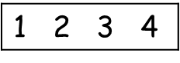  M | Number line
100 | 100 square
 | Dienes
 | Counting objects
 | Numicon
 | Fingers
SC | Self-corrected

