
Anti-Bullying Policy

‘We aspire for all at Parsonage Farm to feel valued and cared for, to have a continued excitement for learning, ensuring success as they journey onwards.’

Our School Values
We follow the rules to keep us happy and safe.
We respect ourselves, others and our school.
We can make the right choices.
We concentrate and listen well.
We try our best even when it is hard.
We think about the feelings of others.
OUR PROMISE
“We will always listen to you.”

Introduction
Parsonage Farm Nursery and Infant School aims to create an environment in which all children feel happy, safe and secure and are able to develop academically, emotionally and socially. We recognise that children must be able to express their worries or concerns knowing that these will be taken seriously and that the appropriate support will be given.

We promote an understanding across the school community that bullying is unacceptable and that action will be taken against it.

We recognise that in any school community there will be disagreements between children which may result in verbal or physical aggression. Such incidents will be addressed initially through the provisions of the school’s Behaviour Policy.

Definition of bullying

At Parsonage Farm Nursery and Infant School we agree to the definition of bullying as defined by The Anti-Bullying Alliance (ABA):
"The repetitive, intentional hurting of one person or group by another person or group, where the relationship involves an imbalance of power. It can happen face to face or online."
There are four key elements to this definition:
- Hurtful
- Repetition
- Power imbalance
- Intentional
Bullying behaviour can be:
- Physical – pushing, poking, kicking, hitting, biting, pinching etc.
- Verbal – name calling, sarcasm, spreading rumours, threats, teasing, belittling.
- Emotional – isolating others, tormenting, hiding books, threatening gestures, ridicule, humiliation, intimidating, excluding, manipulation and coercion.
- Sexual – unwanted physical contact, inappropriate touching, abusive comments, homophobic abuse, exposure to inappropriate films etc.
- Online/cyber – posting on social media, sharing photos, sending nasty text messages, social exclusion.
- Indirect – can include the exploitation of individuals.
Bullying is not:
- A one-off fight between equals
- A falling out between friends
- Hurting someone accidentally
- Borrowing something and forgetting to return

Dealing with Bullying
We always promote the highest expectations of behaviour, self-respect and respect for others. Through Personal, Social and Health Education (our SCARF programme), assemblies and circle time, opportunities are planned specifically to enable children to talk about issues surrounding bullying. They are given clear guidance on what constitutes bullying and through discussion and drama are given the opportunity to rehearse strategies for dealing with bullying.

There are specific KS1 SCARF lessons which cover bullying as can be seen here:
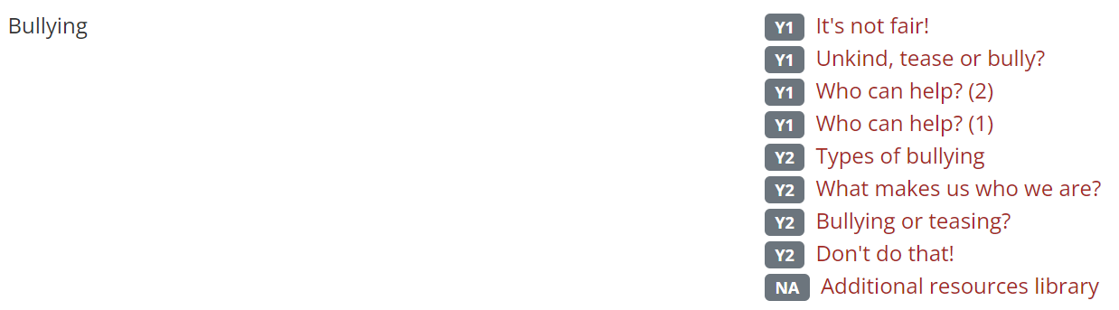
Alongside this SCARF provides teachers with additional resources to use, throughout the year to support the teaching and understanding of bullying.

Children are always encouraged to speak to someone about their worries, and advised that they should tell someone at home, their teacher, another adult in the school, a friend or older pupil.

All reported incidents of bullying will be:
- Investigated and taken seriously by staff members.
- Effectively monitored on a regular basis – all incidents and actions are logged.

The exact course of action will vary with each situation, but the main objectives will be:
- The bully’s behaviour is unacceptable and the bullying must stop.
- If a child feels they are being bullied they can talk to their class teacher or another adult they feel comfortable with.
- The school will work with parents of both the victim and the bully.
- Support will be available for the victim.
- The application of sanctions will depend on the individual circumstances of each incident.
- The school will work with the bully and their family to identify any possible reasons for their behaviour.
- Support will be available for the bully to help change his/her behaviour.
- The parents/carers of bullies and their victims will be informed of an incident and the action that has taken place and asked to support strategies proposed to tackle the problem.
- Any child who needs support with social and friendship skills will be offered help and support in order to learn appropriate social interaction

Monitoring and evaluating the success of the policy
The policy will be monitored and evaluated by:
• Senior Leadership Team (SLT)
• Governors

The policy and/or procedures will, where necessary be revised in light of these evaluations.

This policy should be read in conjunction with all other policies, in particular Equal Opportunities, Race Equality, Teaching and Learning, Behaviour, Child Protection and Safeguarding.

Policy Date: December 2022
Policy Review Date: December 2026

